Homework 7 OOP

Q1

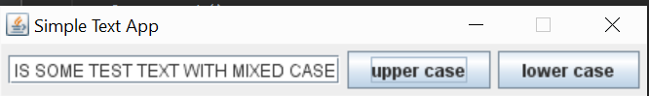

Q2

